CLALLAM MRC MEETING AGENDA
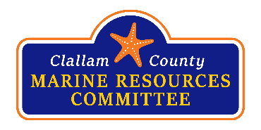 | February 26, 2024  5:30 p.m. – 7:00 p.m.  Hybrid Meeting | 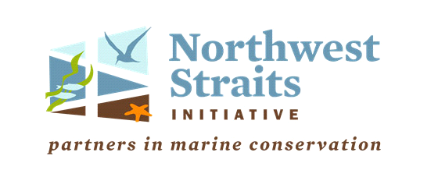

Zoom Meeting Link: https://us06web.zoom.us/j/85314804485
Meeting ID: 853 1480 4485
Passcode: 12345
For more information about the MRC, please contact Rebecca Mahan at (360) 417-2322

5:30 Welcome by Chair Tim Cochnauer

5:35 Call To Order / Introductions / Changes to Agenda

5:40 Public Comment / Approval of Minutes
Approval January minutes.

5:45 Announcements
- Joint meeting with Jefferson County MRC March 6th 5-7:00 pm at Red Cedar Hall.
- Oyster shell transfer/spreading March 4th -7th 7am-3pm at Sequim Bay State Park.
- Ediz Hook Planting event March 26th & 28th Please sign up here.
- River and Ocean Film Festival July 2024 Port Angeles Field and Event Center.

6:00 Presentation
- Lee First, Co-founder and Waterkeeper of Twin Harbors Waterkeeper will give a presentation on the connection and importance of protecting old growth forests along our waterways.

6:20 NWSC Update
NWSC monthly meeting – Alan Clark

6:25 Advisory Role
- Subcommittee status – Jeff Ward

6:30 Field Project Updates
- Olympia Oyster – Chris Burns
- Pigeon Guillemot – Ed Bowlby
- Forage Fish – Tim Cochnauer
- Elwha Beach Stewardship – Helle Andersen
- Kelp surveys – Jeff Ward & Alan Clark
- Shellfish Biotoxins – Bob Vreeland
- Sound Toxins – Nancy Stephanz
- Pinto Abalone – Jeff Ward & Alan Clark
- Ediz Hook – Helle Anderson

6:35 Education/Outreach
- Coasters – Ann Soule – Rebecca has coasters in her office.
- New Displays – Ann Soule
  - Project posters – underway
- Future Presentations:
  - Ideas? Topics?
- Discussion of Proposal to have Alexandra Morton author of “Not on my watch” to speak at CMRC meeting.

6:40 Other Updates/New Topics
- Communication with our County Commissioners – Tim Cochnauer
- Green crab update – CMRC’s Lance Vail and Ioana Bociu volunteered.
- Rescue Tug – Mike Doherty – meeting update from 1/26/24
- Recruiting for open MRC members – Development Community, Marine Related Recreation and Tourism and Makah Tribe.

6:50 Good of the Order
6:55 Public Comment
7:00 Adjourn

Clallam County DCD is inviting you to a scheduled Zoom meeting.

Topic: MRC

Join Zoom Meeting
https://us06web.zoom.us/j/85314804485?pwd=N3dMbHRyL3l5TnpKNGtVSGtWYk5VQT09

Meeting ID: 853 1480 4485
Passcode: 12345
One tap mobile
+12532158782,,85314804485#,,,,*12345# US (Tacoma)

Dial by your location
+1 253 215 8782 US (Tacoma)

